Store Audit Conductor 2.0

Author’s: *Ben Paugh and Carlos Burroughs*

The Azure web application know as the Store Audit Conductor 2.0 enables Lids to perform inventory audits in their stores. It is made up of 6 high level items: Login, Scanner Imports, Reports, Compliance Report, Export, and Logout. The LP Analyst will arrange audits using the D365 Store Audit Calendar. On the day of the scheduled audits, the auditor will follow the steps below to carry out an audit, utilizing the provided Audit ID from the calendar.

# Overall Process

The LP Analyst will schedule the audits using the D365 Store Audit Calendar. On the day of the audit, shortly after sales processing, the Store Audit Calendar Daily Job will initiate, and the job will run for each legal entity in D365 based on the timing of Sales jobs. Its primary functions include entering the price zone and financial dimensions into the Store Audit Calendar, performing the following calculations for audits scheduled that day:

1. SBA (Sales Between Audit)
2. YTD SBA (Year-to-Date Sales Between Audit)
3. Last YTD SBA (Last Year’s Year-to-date Sales Between Audit)
4. YTD audit counts
5. Last YTD audit counts
6. Sales and budget information from YTD start – Audit Date

Additionally, this job will search for any new inventory journals and change the audits associated to those inventory journal’s status in the Store Audit Calendar to ‘Posted’.

Following the completion of the daily job, the SAC Audit Outbound Snapshot job will execute. This comprises three separate tasks:

1. StoreInfo Snapshot
2. Inventory On hand Snapshot
3. Authentication

These jobs are responsible for transmitting the necessary data to the Store Audit Conductor Database. Once these jobs are successfully completed, the auditor is prepared to commence the audit, and the following documentation will provide guidance on how to proceed.

# URL Links

## Prod: [https://storeauditconductor.lids.com/](https://storeauditconductordev.lids.com/)

## UAT: <https://storeauditconductoruat.lids.com/>

## Test: <https://storeauditconductortest.lids.com/>

## Dev: <https://storeauditconductordev.lids.com/>

# Login

Objective:

The purpose is to provide the auditor with instructions on how to log in to the Store Audit Conductor 2.0 using the audit ID supplied from the D365 Store Audit Calendar.

Steps:

1. Click the hamburger on the top right

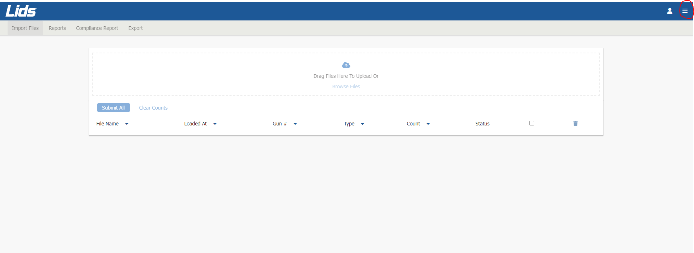

1. A window will appear with documentation options (DC-Console Instructions, DC-Console Guide, Lids Audit Process, and AML Guide), Login button, and outbound job Status

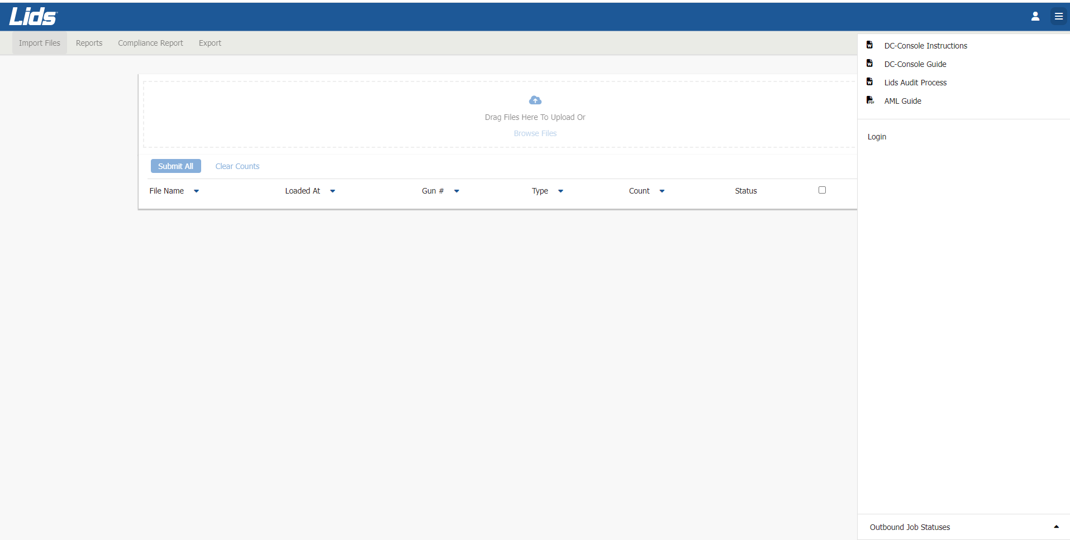

1. Click the ‘Login’ button and a login screen will appear
2. Next, enter the audit ID and verify the auditID by re-entering auditID, provided to you and click ‘Login’

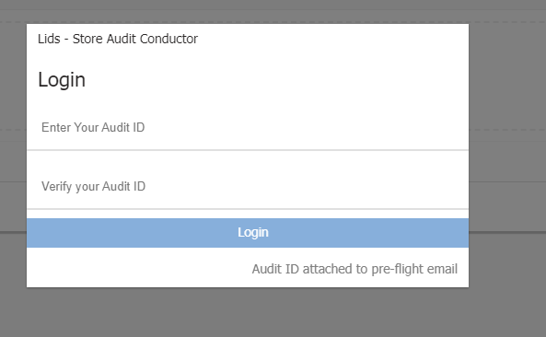

1. Click the hamburger at the top again
2. Click the ‘Outbound Job Status’ dropdown at the bottom. This lets you know if you are ready to conduct an audit. **If one of the three outbound jobs are not ‘Successful’, reach out to IT and they will rerun the appropriate job**

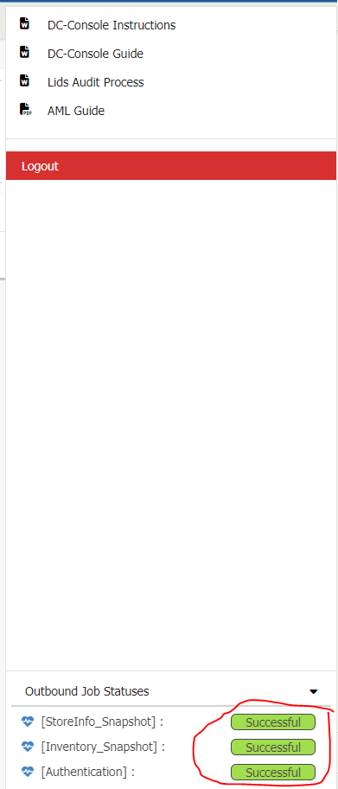

***You are now ready to conduct the audit***

# Scanner Import

Objective:

The purpose is to upload scanner files from the AML or RGIS/WIS scanners, enabling the research of variances and facilitating the processing of an audit.

Steps:

1. In the future we will create a scannerFiles folder on the desktop for auditors, but for now click the ‘Browse Files’ button.

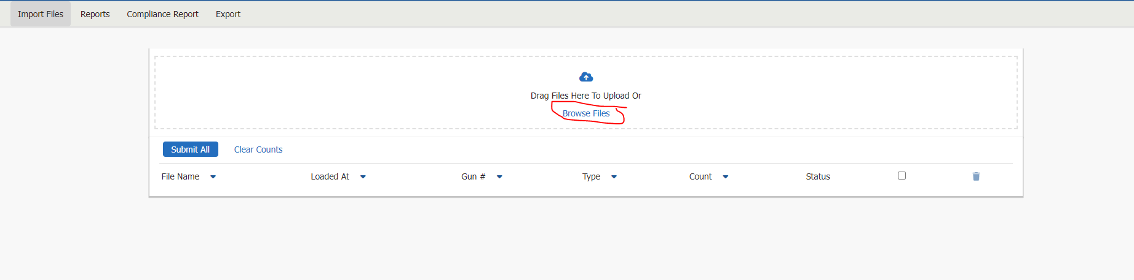

1. Go to the directory where the scanner files are stored, select the scanner files, click Open. This will load all the scanner files into the database (This same process will be done for AML and RGIS/WIS scanners. Auditors will need some adjusting to this process)

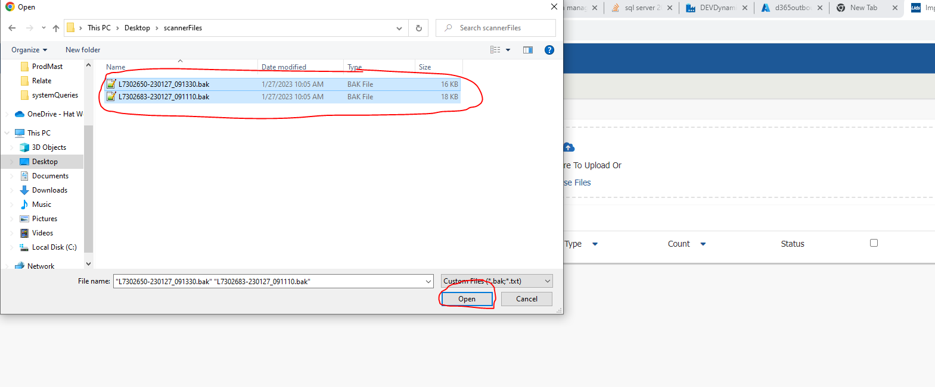

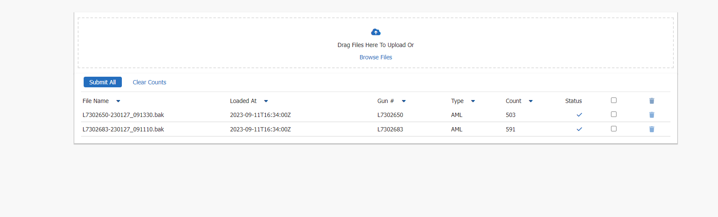

1. If you need to remove all scanner files uploaded, you can click the ‘Clear Counts’ button, or you can click the checkbox at the top right of scanner files list. If you need to remove a single or multiple scanner files you can either click the top checkbox (Check all files), or you can click them individually. This will highlight the trashcan on the right. If you selected all, click the top trash can. If you selected an individual file, click the trash can next to it.

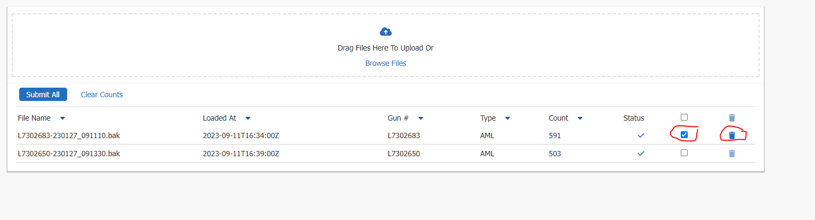

1. When you are ready to submit the scanner files, click ‘Submit All’ button

# Reports

Objective:

The purpose is to give the auditor the necessary information to conduct an audit. Each report allows the auditor(s) to view and verify variances and any other missing data that may have to do with inventory. **(If the report is grayed out it means that the report is not currently implemented.)**

Below you will learn how each report works.

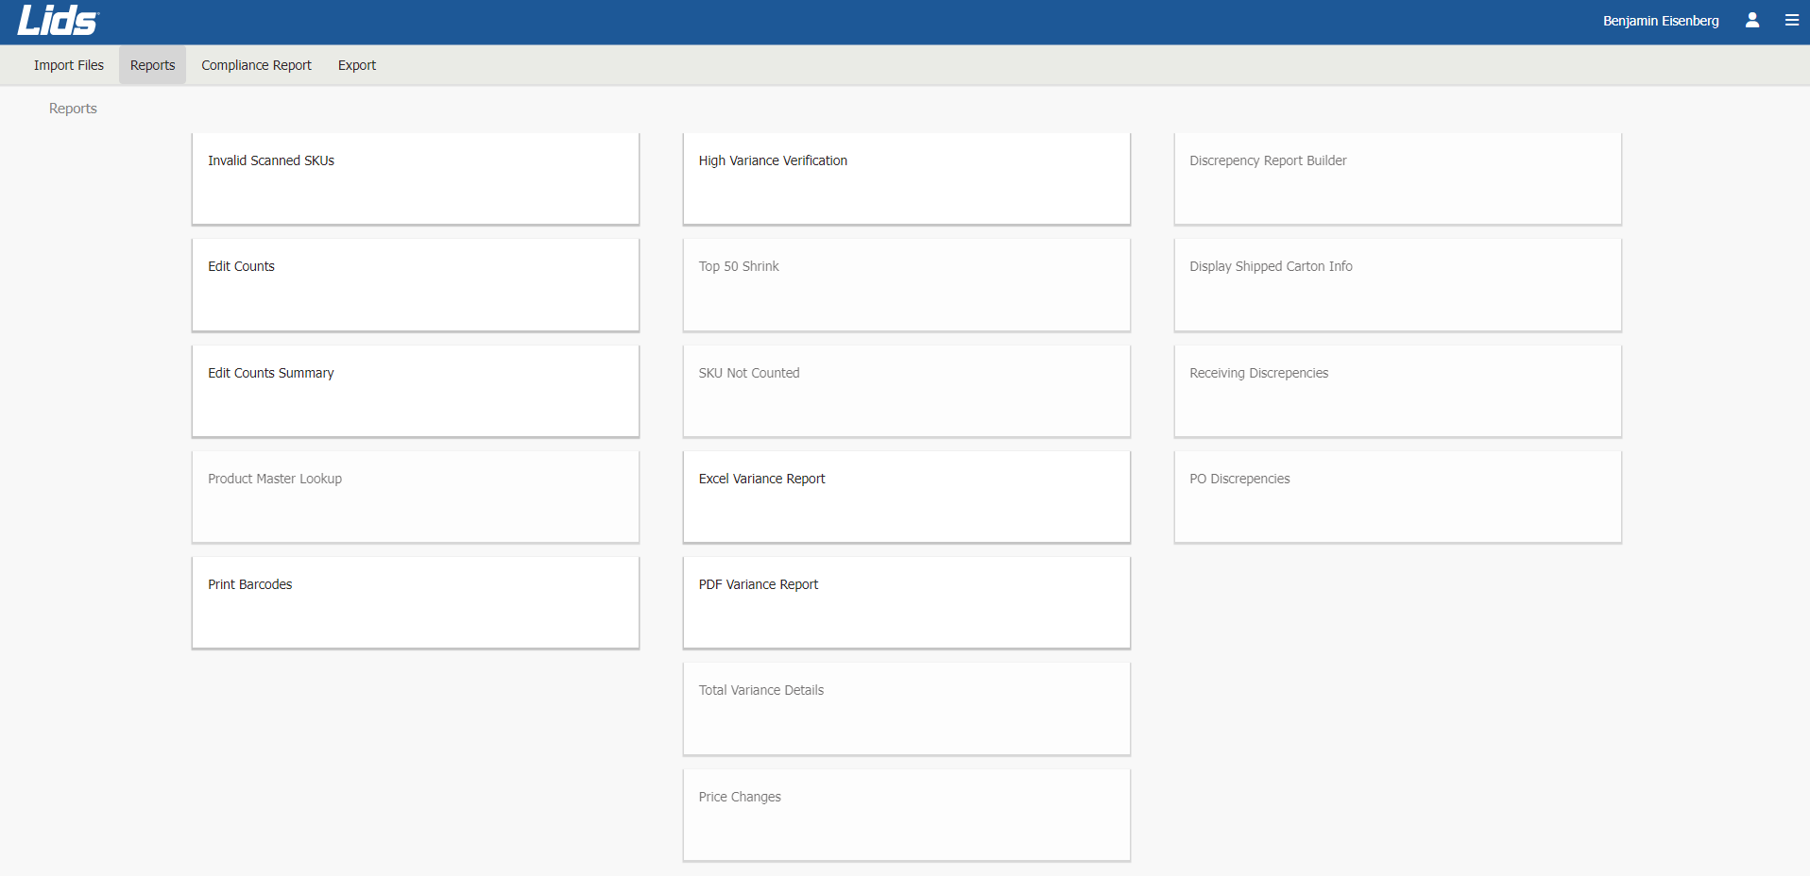

## Invalid Scanned UPCs

Objective:

The objective of this report is to pinpoint all UPCs that were scanned but are not present in the current product master. This will enable the business to identify erroneous labels or missing data that requires correction by the IT department and/or the Buying team.

Steps:

1. Click the ‘Invalid Scanned UPCs report
2. Here is an example of what the report can look like

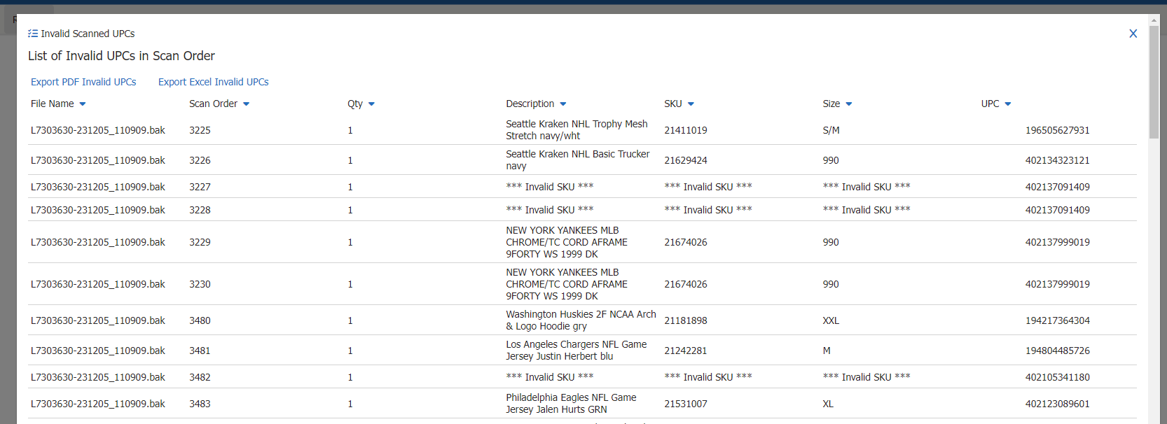

1. Click the ‘Export PDF Invalid UPCs’ button at the top to download a PDF version of the report
2. Click the ‘Export Excel Invalid UPCs’ button at the top to download an Excel version of the report
3. Click the X at the top right or outside the popup window to close the report

## Edit Counts

Objective:

The goal of this report is to empower the auditor to locate specific SKUs or UPCs by searching through the edit counts table and making necessary adjustments to the variances.

Steps:

1. Click the ‘Edit Counts’ Report
2. A window will open to enter one SKU or UPC then click ‘Submit’

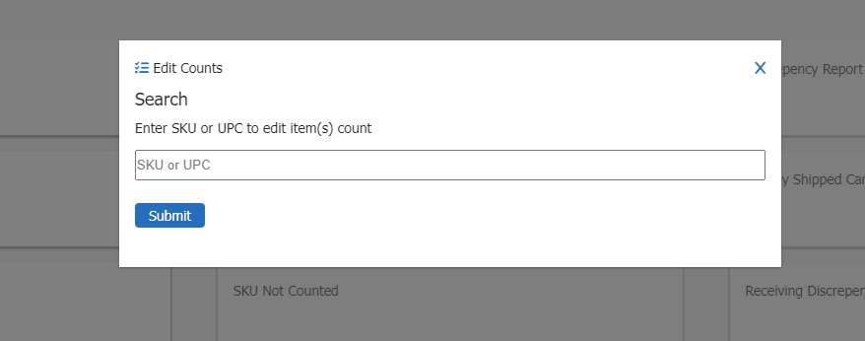

1. This will take you to the Edit Counts item view

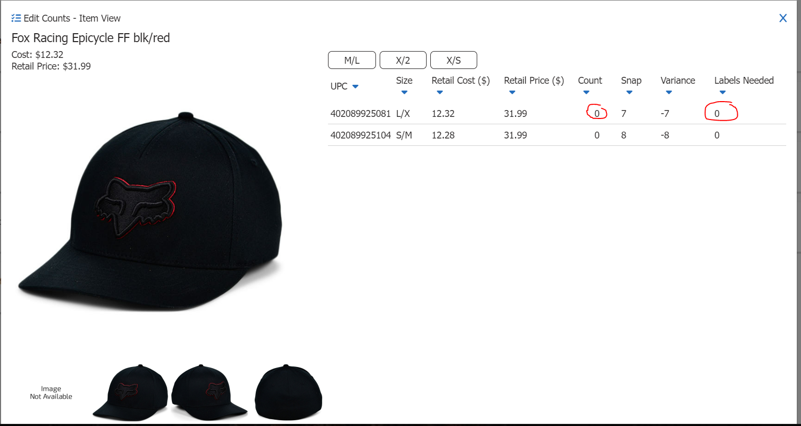

* 1. In this view you can click into the count and modify the count
  2. Click in the labels Needed row and update the number of Labels
  3. Click one of the sizes at the top to add the size to edit counts
  4. Click the images to see different angles of the image

1. Click the X at the top right or outside the popup window to close the report, **everything is automatically saved**

## Edit Counts Summary

Objective:

The purpose of this report is to provide the auditor with the capability to review and investigate variances in a summary format, while also enabling them to edit labels and counts at a SKU/size level when needed. Additionally, auditors can search for products they are researching by SKU, description, or variance.

Steps:

1. Click the Edit Counts Summary Report and you will see the following. **If the description field is blank, then that means it is missing from the product master. Please get with IT, Buying, and Todd Campbell to coordinate.**

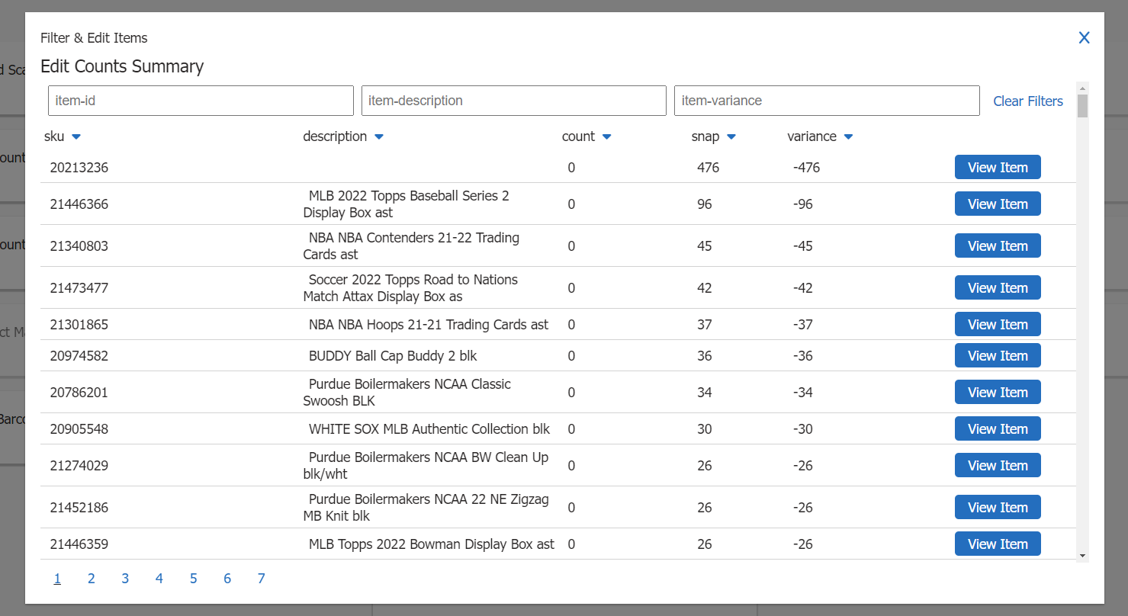

1. Page Numbers:
   1. You will have 1 to many page numbers. Each page on the edit counts summary report is a subset of all edit counts, so think of it as one page at a time.
2. Filters:
   1. User may filter by SKU, description, or variance.
      1. Item ID: can be filtered by any combination of numbers. Example: entering 208 will give you all SKUs that contain 208
      2. Description: Can be filtered by any word, but if you use a phrase, they must be together in the description. Example: User is looking for ‘Black Panther Marvel Dad Hat blk/pur’. The user can type in ‘Black Panther’ and item will show, but they can’t type ‘Black Marvel’. The system will not be able to find this. This is a future enhancement request by LP.
      3. Variance: Can be filtered by any number. Filter will return any number +- greater than or equal to the number entered. Example: user enters 3, the system will return everything -3 and 3 and greater ( -3,-4,-5, 3,4,5)
   2. Clicking ‘Clear Filters’ will remove all filters and return to all item view
3. When user is ready to edit the item, click the ‘View Item’ button associated with that SKU



1. The edit counts item view will appear, and the user can edit the same as the edit counts report
   1. Click in the Counts field to modify the counts
   2. Click in the Labels Needed field to modify the labels
   3. Add a size at the top to add any needed sizes. Adding a size will add the selected size to the edit counts screen, allowing the auditor to add counts to that sku/size.
      1. Modify the Count to the sizes added (Not doing this will add a 0 Count for that item size)
   4. Click the X to close the report or outside the popup window
2. Closing out of the item view screen the items will move to the top of the page, and flash yellow so the user knows where the updated items are.

## Product Master Lookup (Not Implemented)

Objective:

Steps:

## Print Barcodes

Objective:

The purpose of this report is to provide auditors with the ability to print any damaged, incorrect, or missing barcodes at the store during an audit.

Steps:

1. Click the Print Barcodes button to open the report
2. This report will show all the labels added in the edit counts summary report
3. Click the top check box to highlight all the barcodes or click the individual checkboxes to print
4. Click Print Selected Barcodes button. This will download a barcodes file on the Users downloads directory. Save the files in an appropriate location.
5. Click the X to close the report

## High Variance Verification

Objective:

The purpose of this report is to detect any product with a variance +-3 when comparing the scanner count files and the inventory snapshot file. The verification process also includes an auditor’s confirmation that the variances are accurate and justified. **It is required to verify all items in this report before proceeding to export an audit.**

Steps:

1. Click the High Variance Verification report button to open

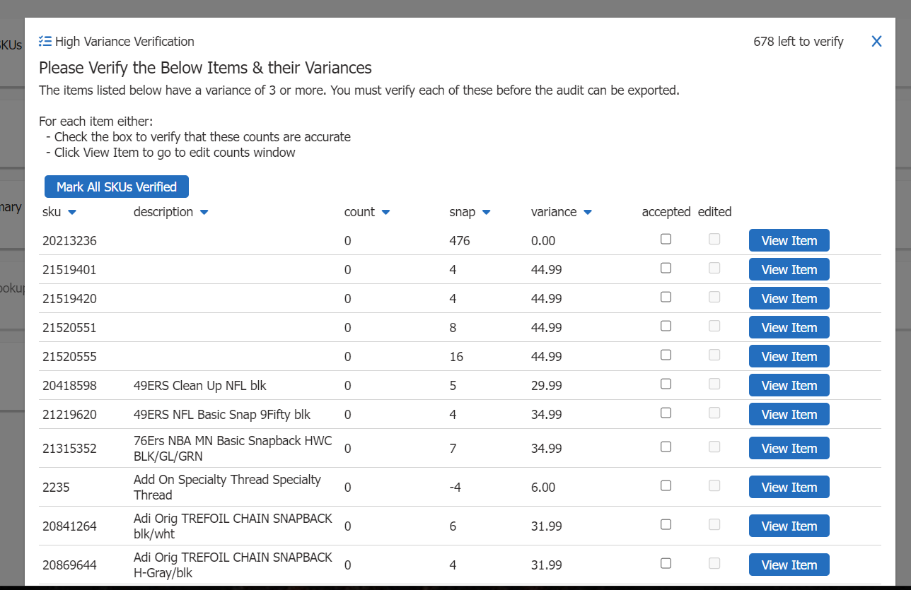

1. User can click the accepted button to accept the high variance
2. User can click the ‘Mark All SKUs Verified’ button to mark all SKUs verified
3. User can click view item button to edit the item. Once the item is edited the edited field will be checked.
4. All SKUs must be verified before an audit can be exported
5. Click the X to close the report or outside the popup window

## Top 50 Shrink (Not Implemented)

## SKU Not Counted (Not Implemented)

## Excel Variance Report

Objective:

The purpose of this report is to present variances based on the +- number entered by the auditor in an Excel format. This report will provide comprehensive information about the specific product. Entering a -1 in the menu will export all variances.

Steps:

1. Click the Excel Variance button to open the Report

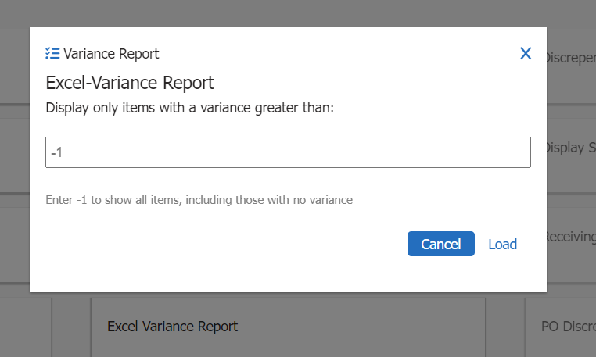

1. Enter a number to download Excel variance file then click Load
2. The menu will close and an excel file will be downloaded into users downloads folder
3. Save the file in the appropriate location
4. The file will consist of all variances +- than the number the user entered
5. **If user wants to see all variances, enter -1**

## PDF Variance Report

Objective:

The purpose of this report is to present variances based on the +- number entered by the auditor in an PDF format. This report will provide comprehensive information about the specific product. Entering a -1 in the menu will export all variances.

Steps:

1. Click the PDF Variance Report button to open the Report

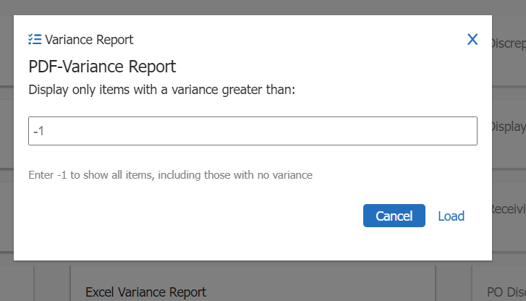

1. Enter a number to download PDF variance file, then click Load
2. The menu will close, and an PDF file will be downloaded into users downloads folder
3. Save the file in the appropriate location (wherever you’d like to store them)
4. The file will consist of all variances +- than the number the user entered
5. **If user wants to see all variances, enter -1**

## Total Variance Details (Not Implemented)

## Price Changes (Not Implemented)

## Discrepancy Report Builder (Not Implemented)

## Display Shipped Carton Info (Not Implemented)

## Receiving Discrepancies (Not Implemented)

## PO Discrepancies (Not Implemented)

# Compliance Report

Objective:

The Compliance Report provides a comprehensive overview of store information, including current audit details, previous audit information, year-to-date (YTD) audit information, last year’s YTD audit information, and all the necessary store operation compliance information that the auditor is required to input before exporting.

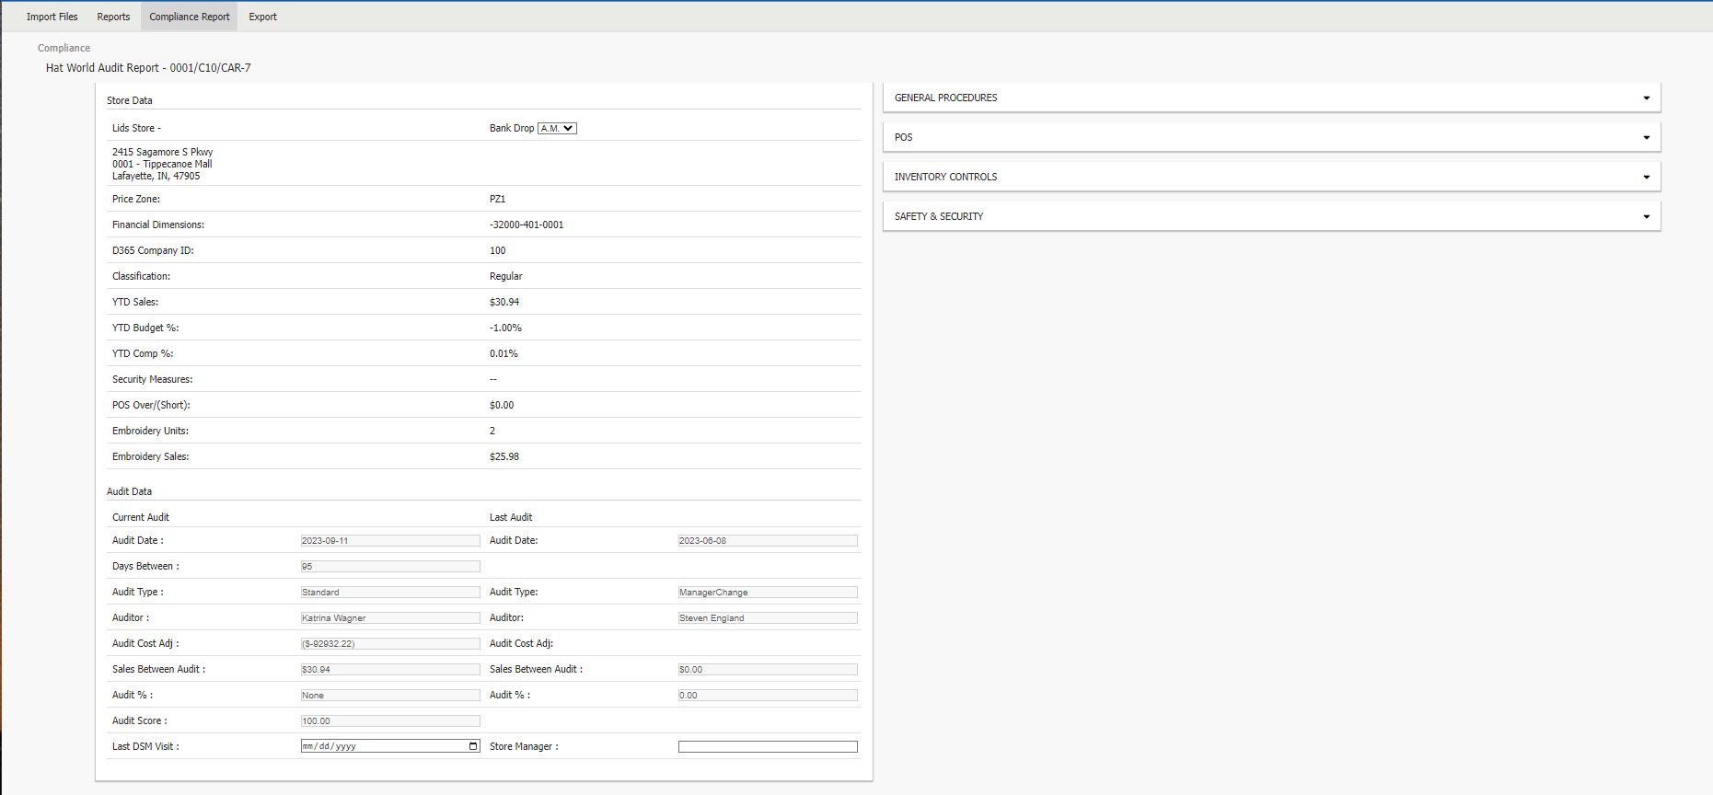

The Store Data section comprises all store information sourced from D365. While much of the data remains consistent with SAC1.0, we have included additional elements such as Price Zone, Financial Dimensions, and D365 Company ID specifically for reporting purposes.

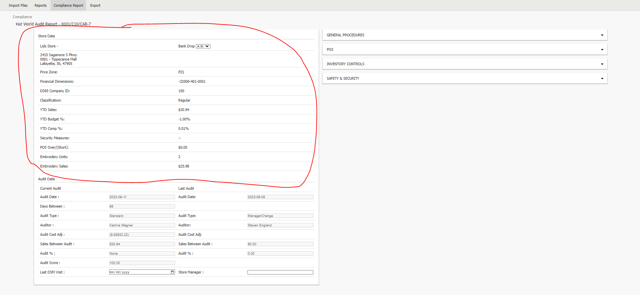

The Audit Data section encompasses information related to the specific audit. While the majority of this data is sourced from D365, the Audit Cost Adjustment field and the Audit Percentage field are computed based on variances found in the Edit Counts Summary Report. Additionally, the Audit Score is determined by the selections made in the Store Operations procedure section located on the right.

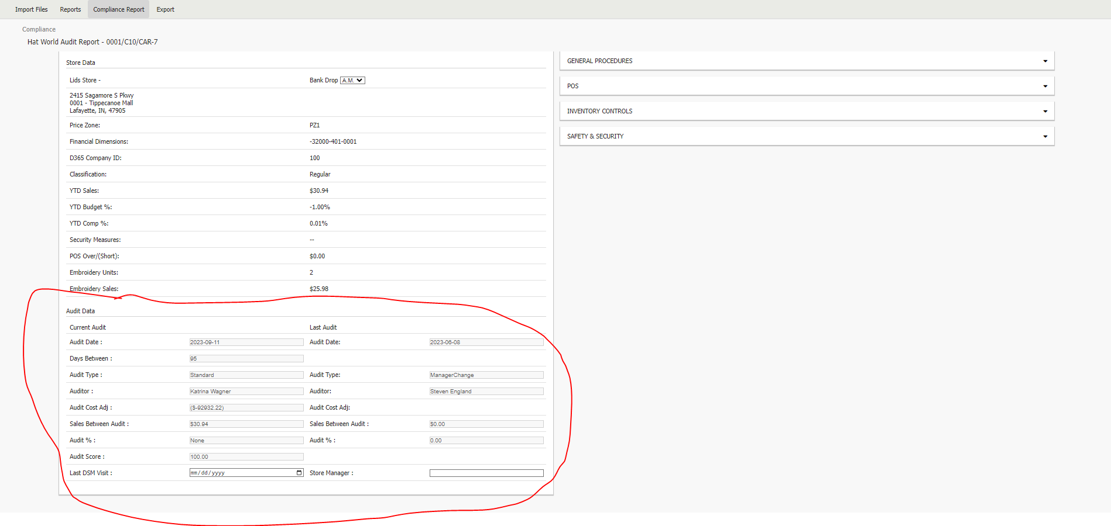

Steps:

1. Enter in the Last DSM Visit date on the bottom left
2. Enter in the Store Manager Name on the bottom left
3. Next, Click the 4 sub menu bars (General Procedures, POS, Inventory Controls, Safety & Security) on the right to open them. You will notice a list of Store Operations.

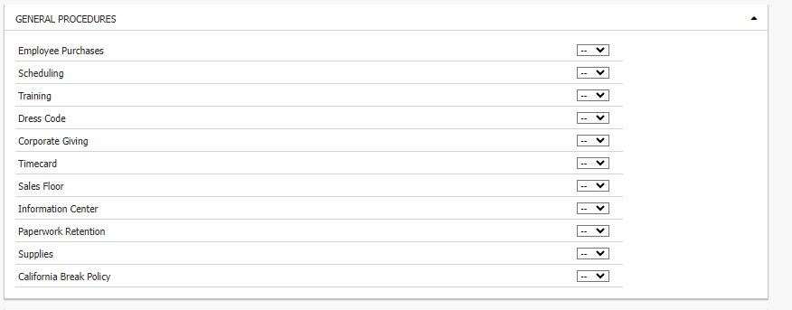

1. Select the drop down on each store operation and select the correct value A (Approved), UA (Unapproved), NA (Not Applicable).
   1. If UA is selected a sub menu will appear with the list of Exception items

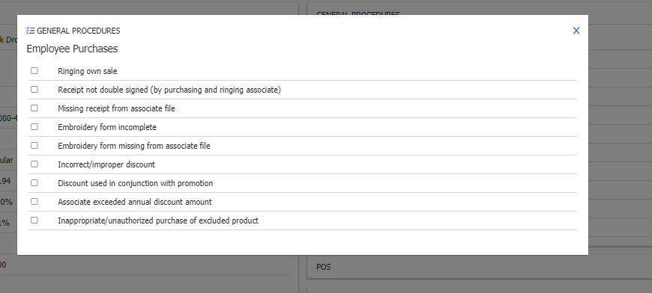

* 1. Select the necessary exceptions
  2. Click X to close the menu

1. You will notice the audit % changed when there are UA’s

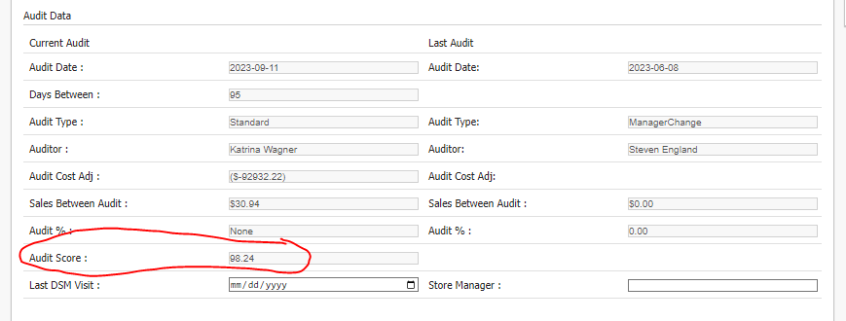

NOTE: Last DSM Visit, Store Manager, and all Store Operations must have a value before the user can go to the Export step

# Export

Objective:

The Export page serves as a condensed version of the compliance report to be exported in PDF format and emailed composed by the auditor to the appropriate business stakeholders. It encompasses comprehensive store details, both current and previous audits, year-to-date (YTD) audit data, the last YTD audit data, department specifics, and store operational compliance information.

On this page, the user will have visibility into all the A (Approved), UA (Unapproved), and NA (Not Applicable) items from the compliance report, in addition to the exceptions outlined in the Exceptions section.

Steps:

1. Enter any general Comments the user might want to provide to the business by clicking the pencil on the far right of General Comments

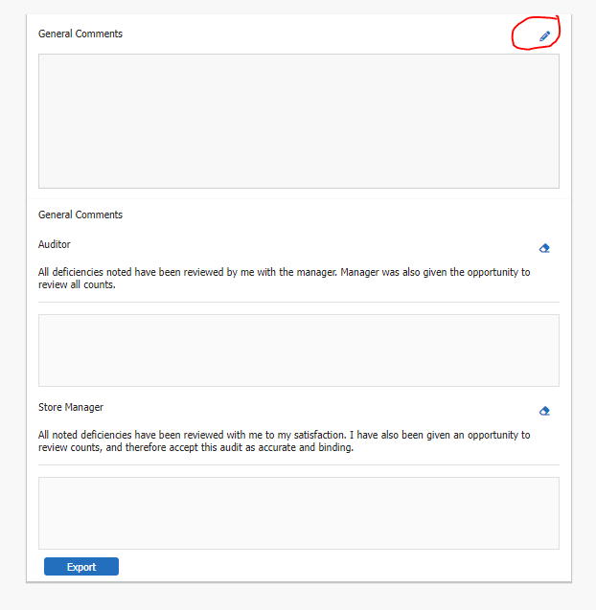

1. Next, the audit and the store manager must sign the audit report using the mouse. To do so, left click in the designated area and sign your name. If there was a mistake, click the blue eraser on the right to erase. **The auditor and Store Manager signature must be filled in before the audit can be exported.**
2. When you are ready to export, click the blue export button.
   1. This will download a copy of the PDF to the users download folder. Move the file to the appropriate folder and manually attach in an email. (**There are future requirements to automate this so email is sent automatically.)**
   2. The export button will put the inventory data in the appropriate database table to be imported into D365 at 10:00 PM Est.
   3. Reporting needs to be built out to let the business know the information that was exported.

# Logout

Objective:

The purpose of the logout section is to serve as a reminder for the auditor to ensure they sign out of the audit at the end. This is important to prevent data loss and to avoid any accidental use of this audit for their next audit.

Steps:

1. When the user is ready to Logout, click the hamburger menu at the top right.
2. Click the Logout button.

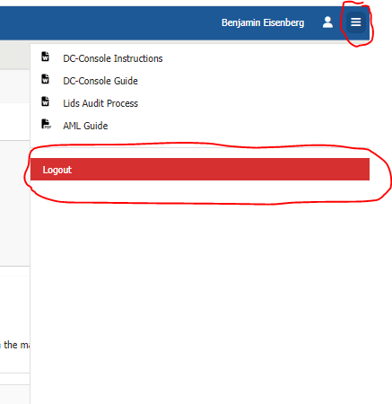

1. A user will be able to log back into the audit during a timeframe decided by the business.
   1. User will use same Audit ID to log back in.